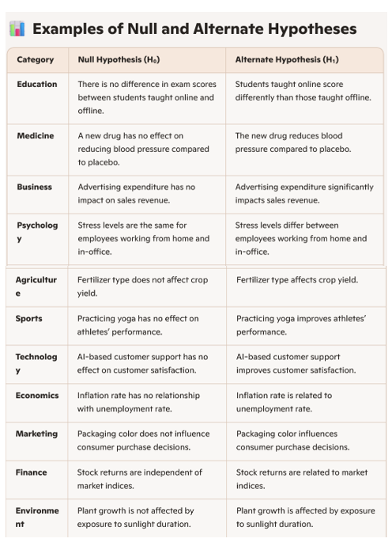

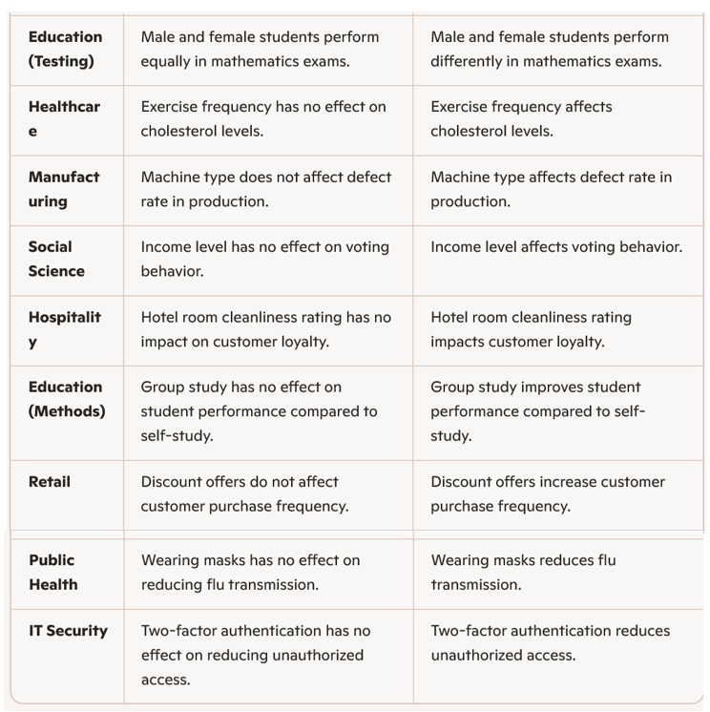Example:
- Education: Do students who study in groups score higher than those who study alone?
- Sports: Does a new training method improve sprint speed?
- Health: Does drinking green tea lower blood pressure?
  - Suppose you believe a coin is unfair (biased).
  - Your friend says it’s fair.
  - You flip the coin many times to check.
- This sets the stage: hypothesis testing is about checking claims with evidence.

2. Define the Two Hypotheses
- Null Hypothesis (H₀): The default assumption — “Nothing unusual is happening.”
  - Example: The coin is fair.
- Alternate Hypothesis (H₁): The challenger — “Something different is happening.”
- Example: The coin is biased.
3. Explain the Process in Simple Steps
- Make a claim (H₀ vs H₁).
- Collect data (flip the coin, measure exam scores, record blood pressure).
- Analyze data (use statistical tests).
- Decide:
- If evidence is strong → reject H₀ (support H₁).
- If evidence is weak → fail to reject H₀ (stick with the default).

A hypothesis is a clear, testable statement predicting the relationship between variables. It is essential in research because it provides direction, focus, and a basis for statistical testing. Hypotheses can be classified into several types, including null, alternative, simple, complex, directional, and non-directional.
Hypothesis = testable prediction.
• Need = direction, clarity, and statistical testing.
• Types = null, alternative, simple, complex, directional, non-directional, associative, causal.
• In quantitative research, hypotheses are central because they can be tested statistically.
🔹 What is a Hypothesis?
• A hypothesis is a tentative assumption or prediction about the relationship between variables.
• It is testable and can be verified or rejected through data collection and analysis.
• Example: “Students who study in night score higher than those who don’t.”
🔹 Need for a Hypothesis
• Guides research: Provides a clear focus and direction for investigation.
• Defines variables: Identifies dependent and independent variables for study.
• Facilitates testing: Enables use of statistical methods to confirm or reject assumptions.
• Improves clarity: Helps researchers avoid vague exploration and concentrate on specific questions.
• Links theory and practice: Connects abstract concepts with measurable outcomes.

🔹 Types of Hypotheses
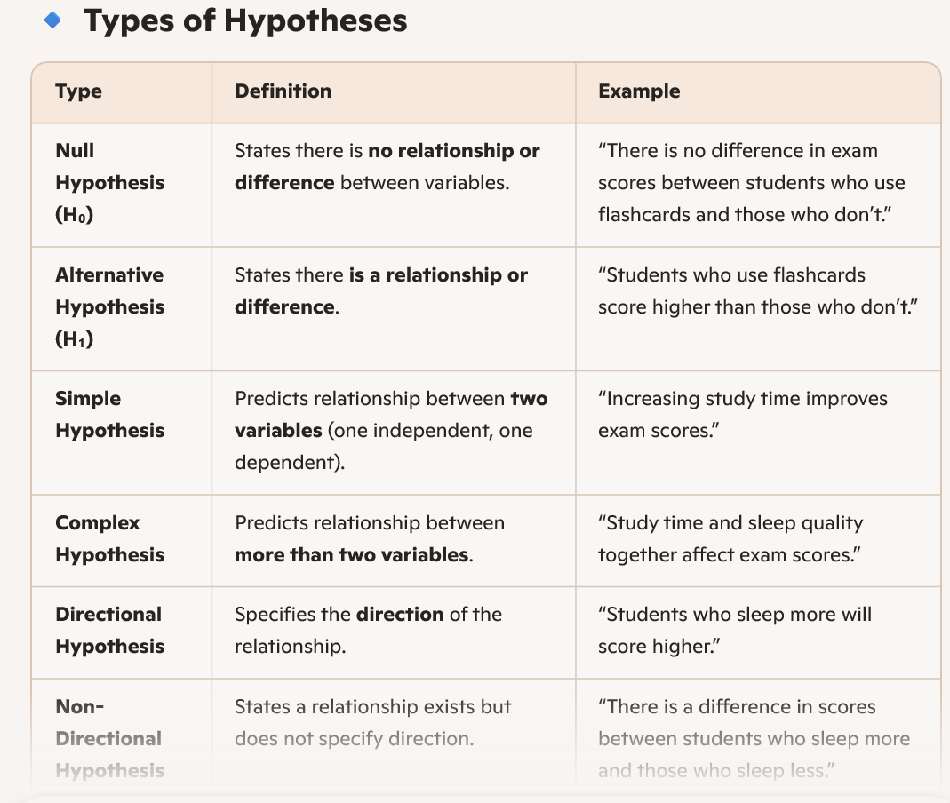
🔹 Descriptive Hypothesis
A descriptive hypothesis predicts the characteristics or behavior of a single variable. It does not explore relationships between variables — it simply describes what is expected.
📌 Purpose: To describe a phenomenon, trait, or behavior.
- Often used in exploratory research or surveys.
🧠 Example:
- “60% of college students prefer online learning over classroom learning.”
- “The average height of adult males in Karnataka is 5 feet 7 inches.”
📊 Use Case:
- When you want to estimate proportions, averages, or frequencies.
- Common in market research, demographic studies, and descriptive statistics.
🔹 Relational Hypothesis
✅ Definition:
A relational hypothesis predicts a relationship between two or more variables. It can be correlational (association) or causal (cause-effect).
📌 Purpose:
- To test associations or dependencies.
- Used in analytical and experimental research.
🧠 Example:
- “There is a positive relationship between study time and exam scores.”
- “Employee satisfaction increases with flexible working hours.”
🔄 Types:
- Correlational: Variables move together (e.g., income and spending).
- Causal: One variable affects another (e.g., training improves productivity).
📊 Use Case:
- When you want to test theories, models, or predictions.
- Common in psychology, economics, education, and management research.
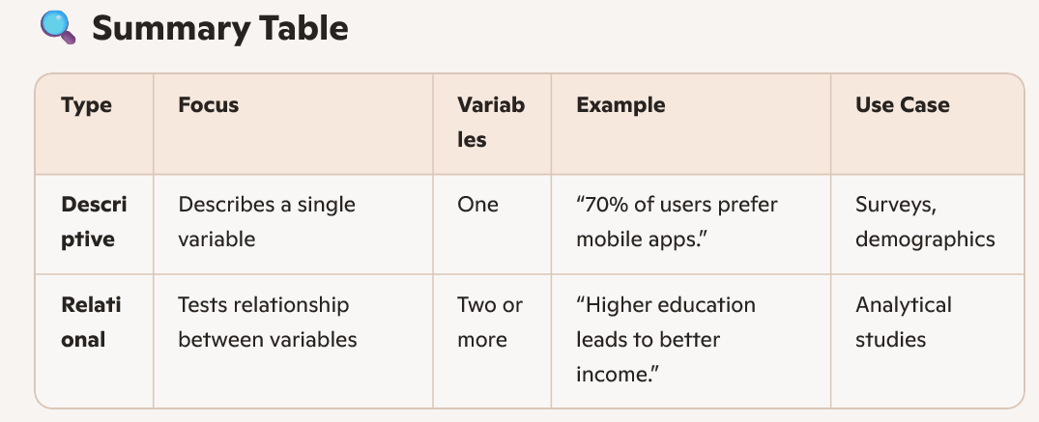

Parametric tests assume data follows a specific distribution (usually normal) and use population parameters like mean and variance, while non-parametric tests make fewer assumptions and are suitable for ordinal data or non-normal distributions. Parametric tests are more powerful when assumptions hold, but non-parametric tests are safer when data is skewed, small, or categorical.
🔹 Key Differences Between Parametric and Non-Parametric Tests
🔹 Classification of Tests
Parametric Tests
- t-tests
  - Independent samples t-test: Compare means of two independent groups.
  - Paired t-test: Compare means of the same group at two times.
- ANOVA (Analysis of Variance)
  - Compare means across more than two groups.
- Pearson’s correlation
  - Measures linear relationship between two continuous variables.
- Linear regression
- Predicts dependent variable from independent variable(s).
Non-Parametric Tests
- Chi-square test
  - Tests association between categorical variables.
- Mann-Whitney U test
  - Compares two independent groups (alternative to independent t-test).
- Wilcoxon signed-rank test
  - Compares paired samples (alternative to paired t-test).
- Kruskal-Wallis test
  - Compares more than two independent groups (alternative to ANOVA).
- Spearman’s rank correlation
- Measures monotonic relationship between two variables.
🔹 When to Use Each
- Use Parametric Tests when:
  - Data is normally distributed.
  - Variables are measured on interval/ratio scales.
  - Sample size is large enough to satisfy assumptions.
  - Variances across groups are equal (homoscedasticity).
- Use Non-Parametric Tests when:
- Data is ordinal or nominal.
- Distribution is skewed or unknown.
- Sample size is small.
- Assumptions of parametric tests are violated.
🔹 Practical Example
- If you want to compare average exam scores of two classes (continuous, normally distributed) → Independent t-test.
- If you want to compare customer satisfaction ratings (ordinal scale, not normally distributed) → Mann-Whitney U test.
- If you want to test association between gender and product preference (categorical variables) → Chi-square test.
Would you like me to create a flowchart-style decision guide (visual aid) that shows which test to use based on data type and assumptions? That could make it easier for your students or trainees to quickly decide.

🎓 Problem Statement
A professor claims that the average exam score of her class is 75.
You collect a random sample of 20 students and find:
• Sample mean () = 78
• Sample standard deviation (s) = 10
You want to test whether the professor’s claim is correct at 5% significance level ().

Step 1: Define Hypotheses
Two-tailed test (general difference)
• (population mean is 75)
• (population mean is not 75)
One-tailed test (greater than claim)
•
•

Step 2: Test Statistic Formula

Where:
• = sample mean = 78
• = hypothesized mean = 75
• = sample standard deviation = 10
• = sample size = 20

Step 3: Degrees of Freedom

Step 4: Critical Values
• For two-tailed test at :
Critical
• For one-tailed test at :
Critical

Step 5: Decision
• Two-tailed test:
Calculated is less than 2.093 → Fail to reject .
👉 No evidence that the mean is different from 75.
• One-tailed test:
Calculated is less than 1.729 → Fail to reject .
👉 No evidence that the mean is greater than 75.

✅ Conclusion
• In both one-tailed and two-tailed tests, we fail to reject the null hypothesis.
• The sample does not provide strong enough evidence to conclude that the average score differs from or is greater than 75.

Would you like me to also prepare a step-by-step flowchart or decision tree (visual aid) showing how to choose between one-tailed and two-tailed t-tests? That would make it easier for students to grasp the logic quickly.

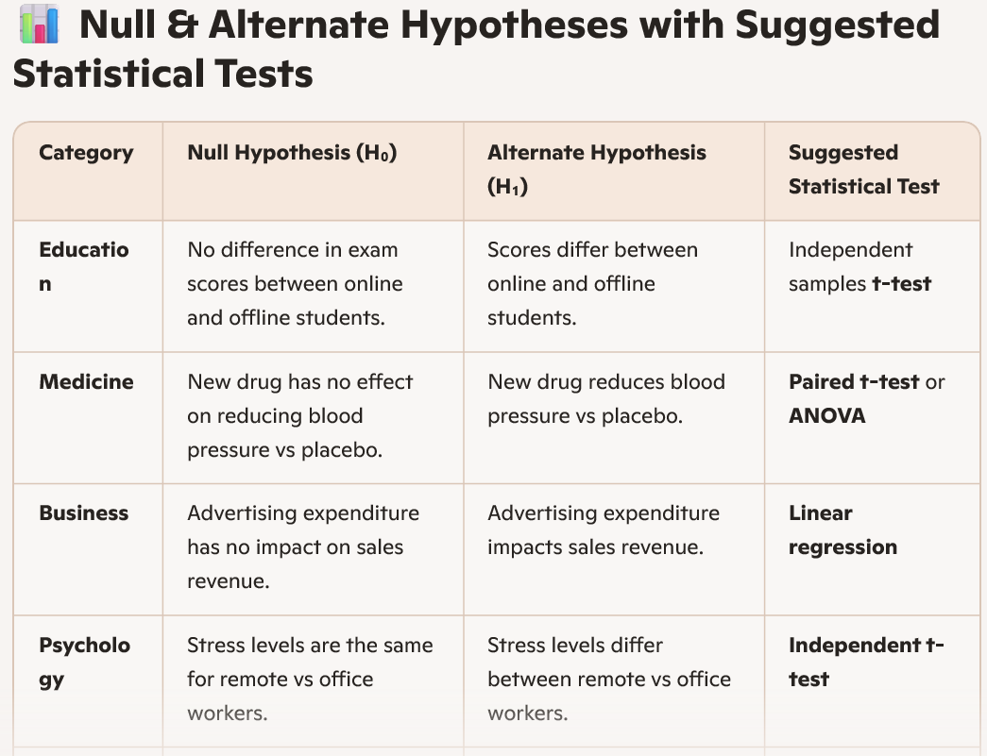
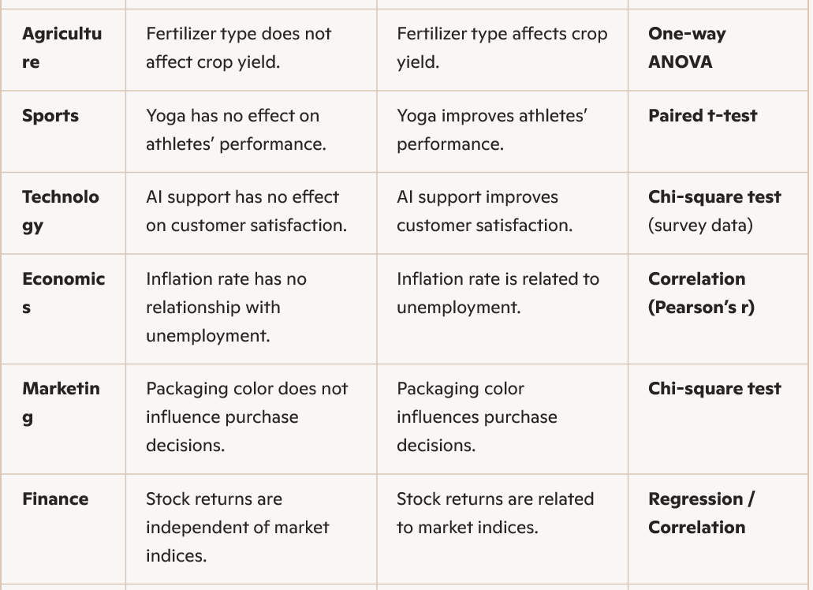
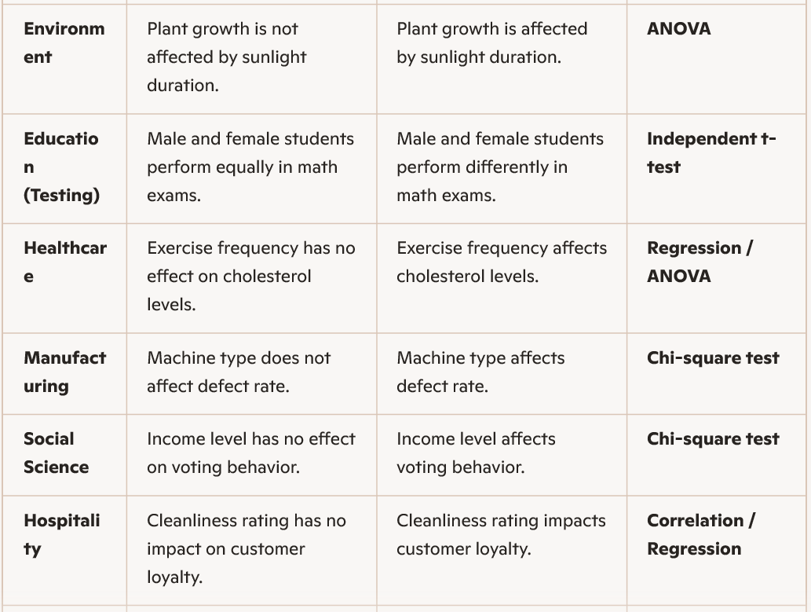
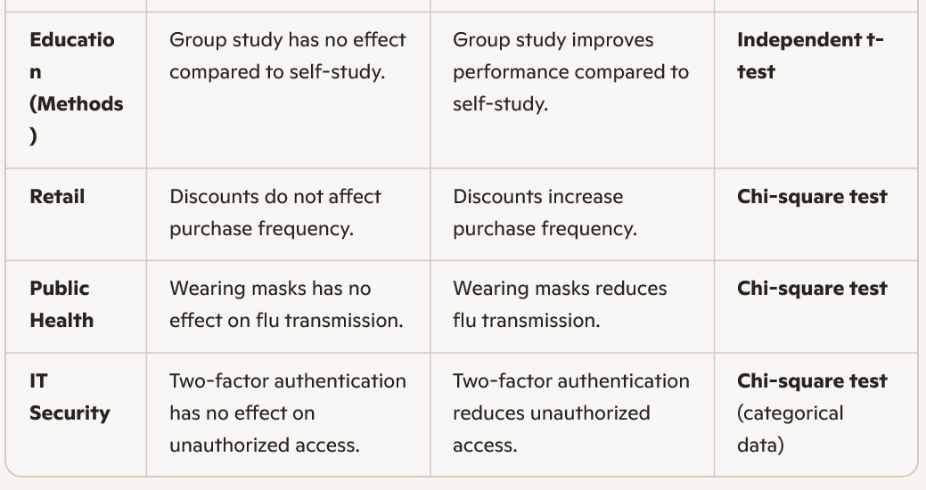
1. Nominal Variables (no inherent order) : Nominal categorical variables → Just labels, no ranking.
- Gender: Male, Female, Other
- Blood type: A, B, AB, O
- Marital status: Single, Married, Divorced, Widowed
- Religion: Hindu, Muslim, Christian, Sikh, Buddhist
- Nationality: Indian, American, Japanese, Brazilian
- Eye color: Brown, Blue, Green, Hazel
- Vehicle type: Car, Bike, Truck, Bus
- Payment method: Cash, Credit Card, UPI, Net Banking
- Fruit type: Apple, Banana, Mango, Orange
- City of residence: Belagavi, Bengaluru, Mumbai, Delhi

2. Ordinal Variables (categories with a meaningful order): Labels with a natural order.
- Education level: Primary, Secondary, Graduate, Postgraduate, Doctorate
- Customer satisfaction: Very Unsatisfied, Unsatisfied, Neutral, Satisfied, Very Satisfied
- Socioeconomic status: Low, Middle, High
- Movie rating: 1 star, 2 stars, 3 stars, 4 stars, 5 stars
- Pain severity: Mild, Moderate, Severe
- Academic grade: A, B, C, D, F
- Age group: Child, Teen, Adult, Senior
- Job position: Intern, Junior, Senior, Manager, Director
- Likert scale responses: Strongly Disagree → Strongly Agree
- Clothing size: Small, Medium, Large, Extra Large

4. Introduce Key Terms
- Significance level (α): Threshold for deciding (often 0.05).
- p-value: Probability of seeing the data if H₀ is true.
- Type I error: Rejecting H₀ when it’s actually true.
- Type II error: Failing to reject H₀ when H₁ is true.
6. Visual Aid
Show a flowchart:
Start → State H₀ & H₁ → Collect Data → Choose Test → Calculate p-value → Compare with α → Decision

7. Emphasize the Philosophy
- Hypothesis testing is not about proving something 100% true.
- It’s about using data to make informed decisions with controlled risk.

Great question! The t-test and z-test are both statistical tests used to compare sample means, but they are applied under different conditions. Let me break it down clearly:
🔹 Z-Test
- When used:
  - Population variance (\sigma ^2) is known.
  - Sample size is large (generally n>30).
  - Data is approximately normally distributed.
- Applications:
  - Comparing a sample mean to a population mean (one-sample z-test).
  - Comparing two sample means (two-sample z-test).
  - Testing proportions (z-test for proportions).
- Example:
Suppose you know the population standard deviation of exam scores is 10, and you want to test if your class’s average score differs from the national average. → Use a z-test.
🔹 T-Test
- When used:
  - Population variance (\sigma ^2) is unknown.
  - Sample size is small (n<30).
  - Data is approximately normally distributed.
- Applications:
  - One-sample t-test: Compare sample mean to population mean.
  - Independent two-sample t-test: Compare means of two independent groups.
  - Paired t-test: Compare means of related groups (before/after studies).
- Example:
You don’t know the population standard deviation of blood pressure readings, and you want to test if a new drug changes average blood pressure in a small sample of 20 patients. → Use a t-test.
⚖️ Key Difference Table
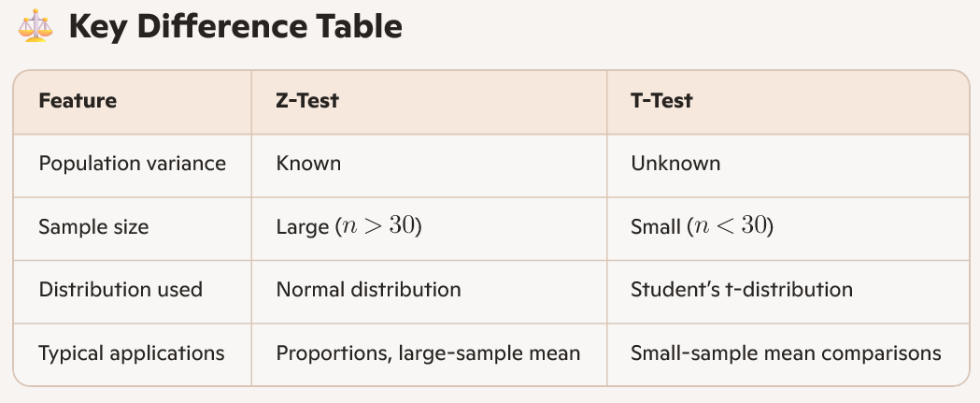
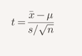
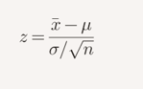
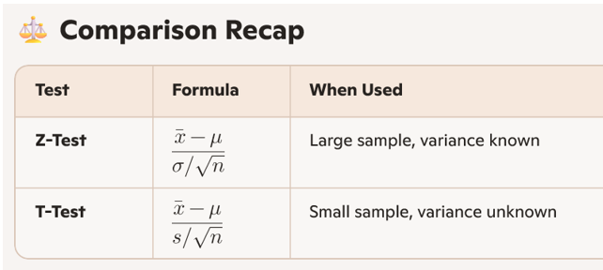
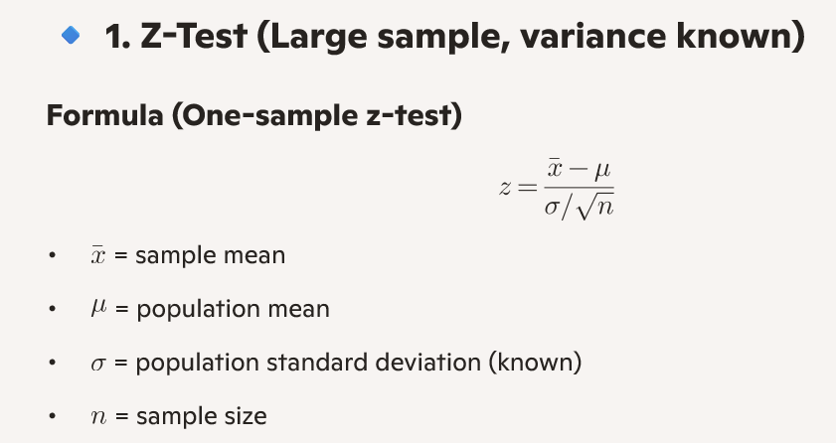
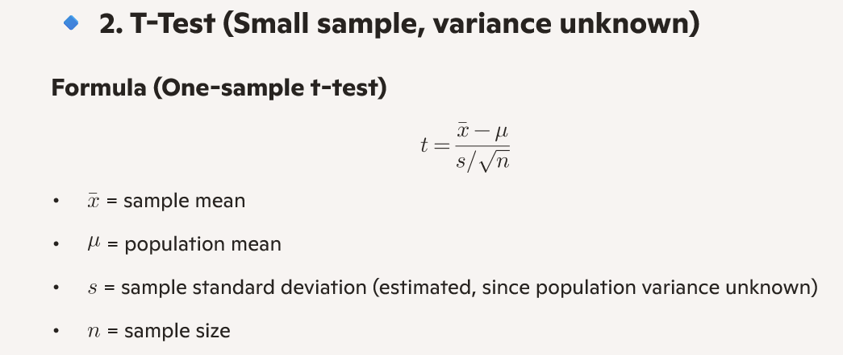
- Z-test = large sample, variance known.
- T-test = small sample, variance unknown.

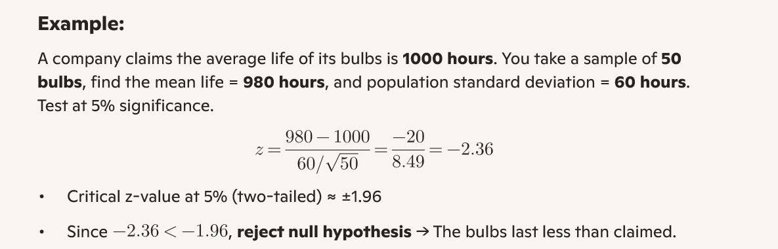

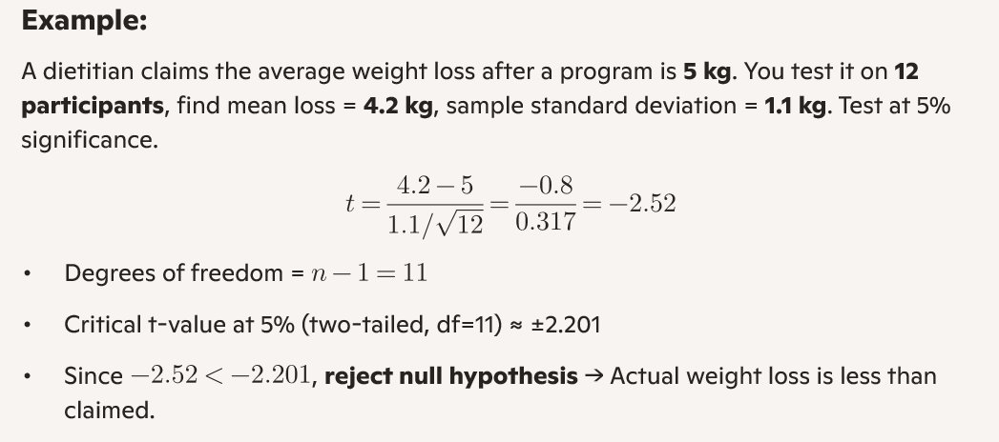
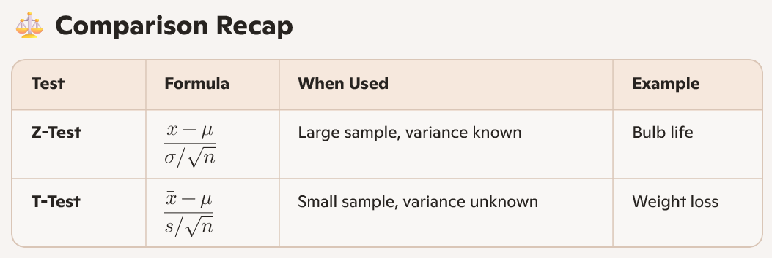

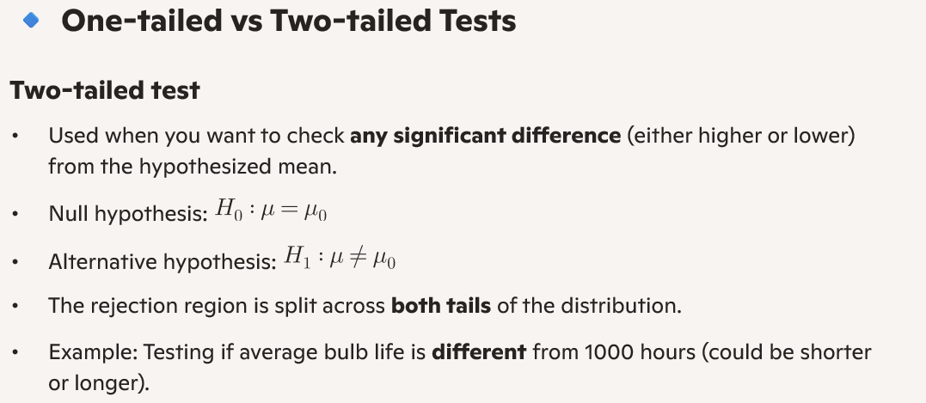
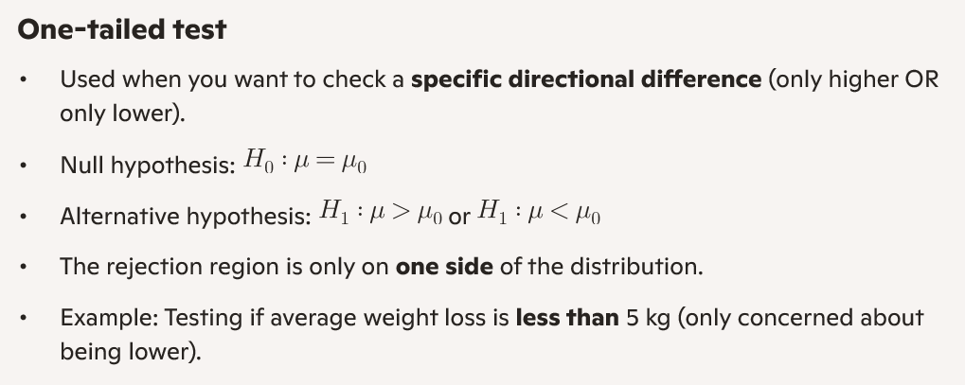

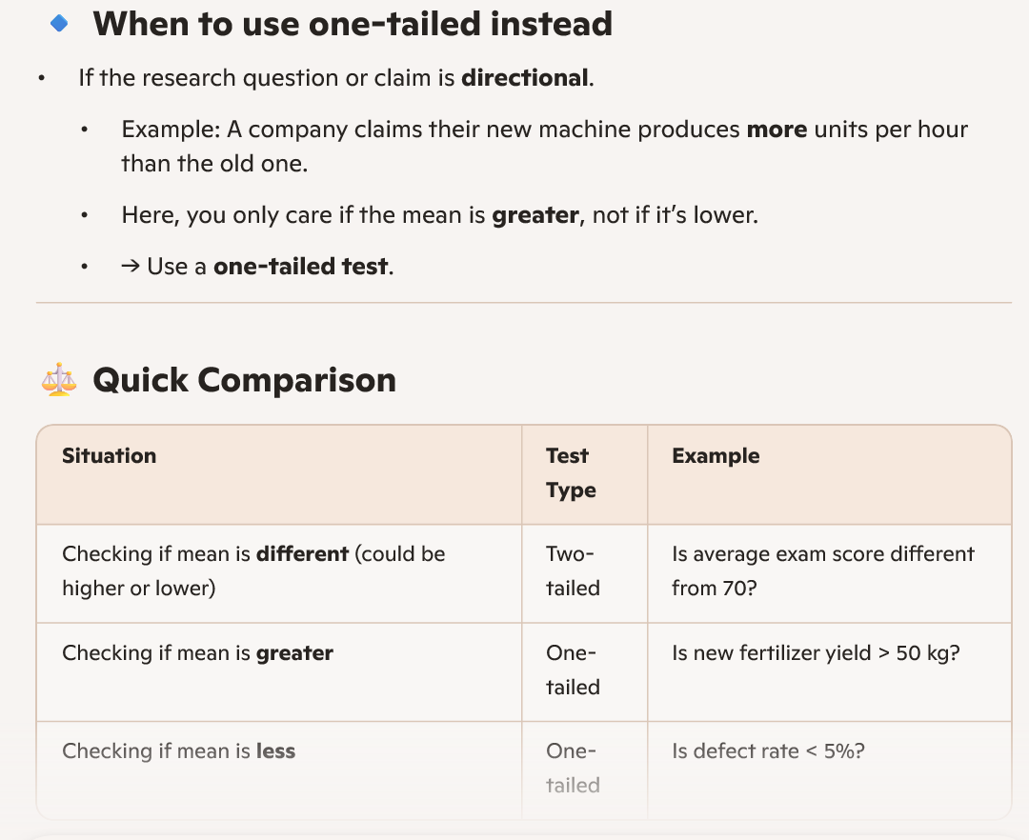

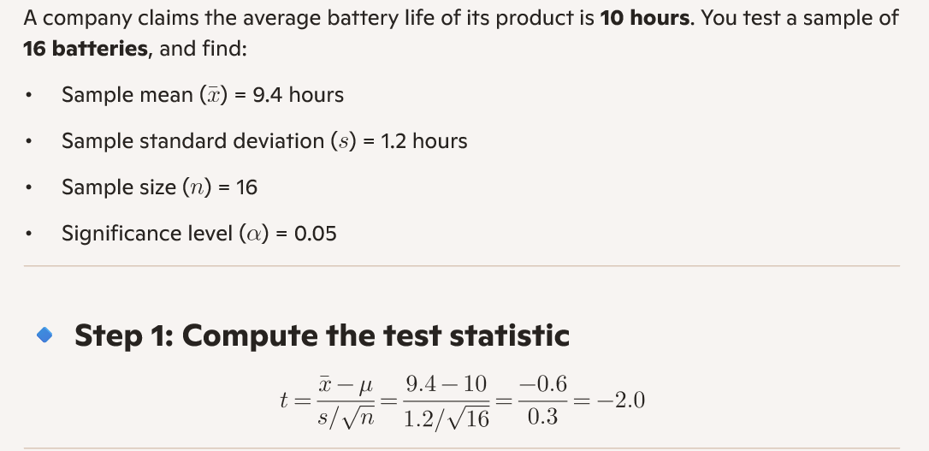

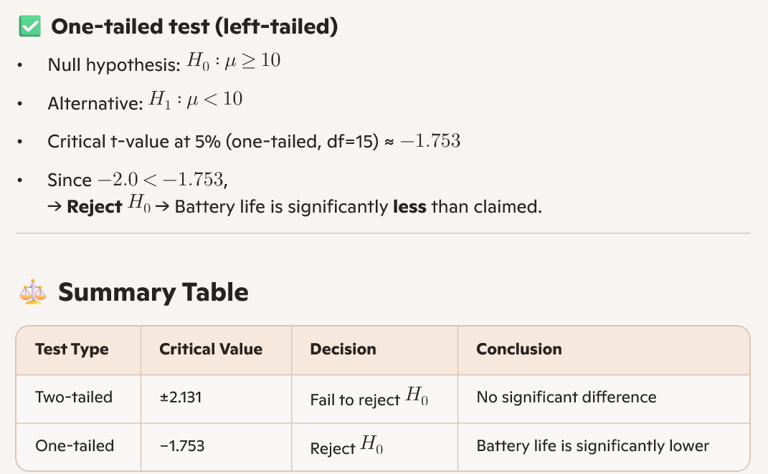
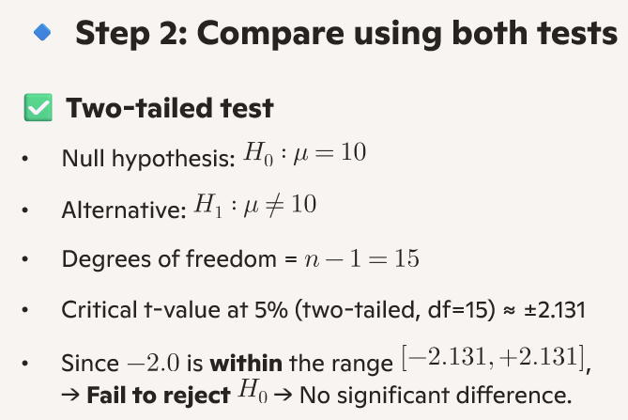

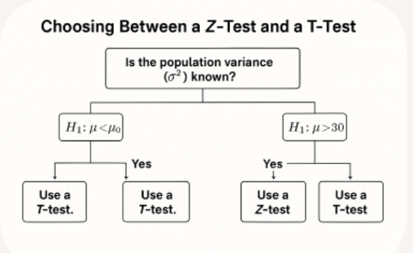

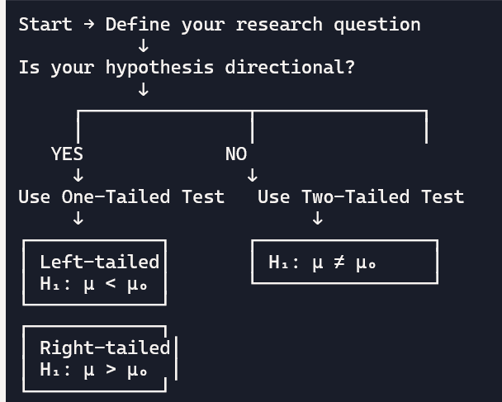
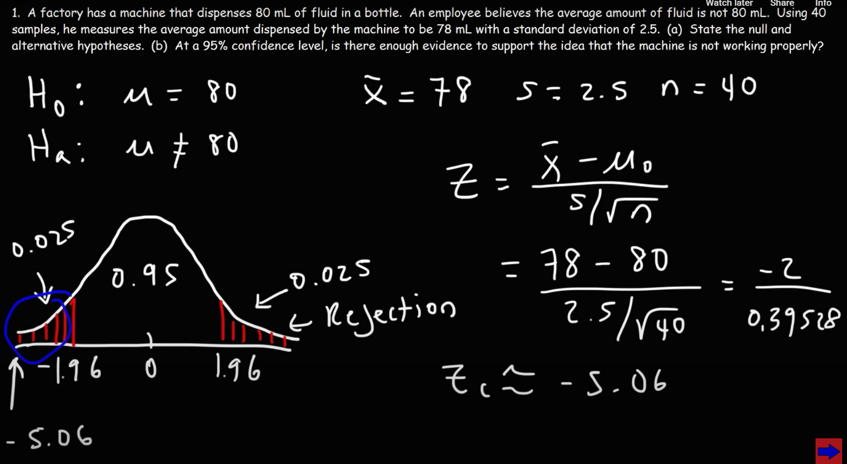

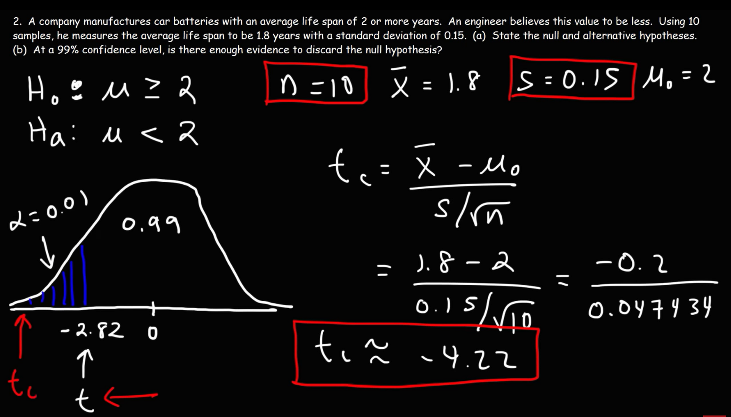
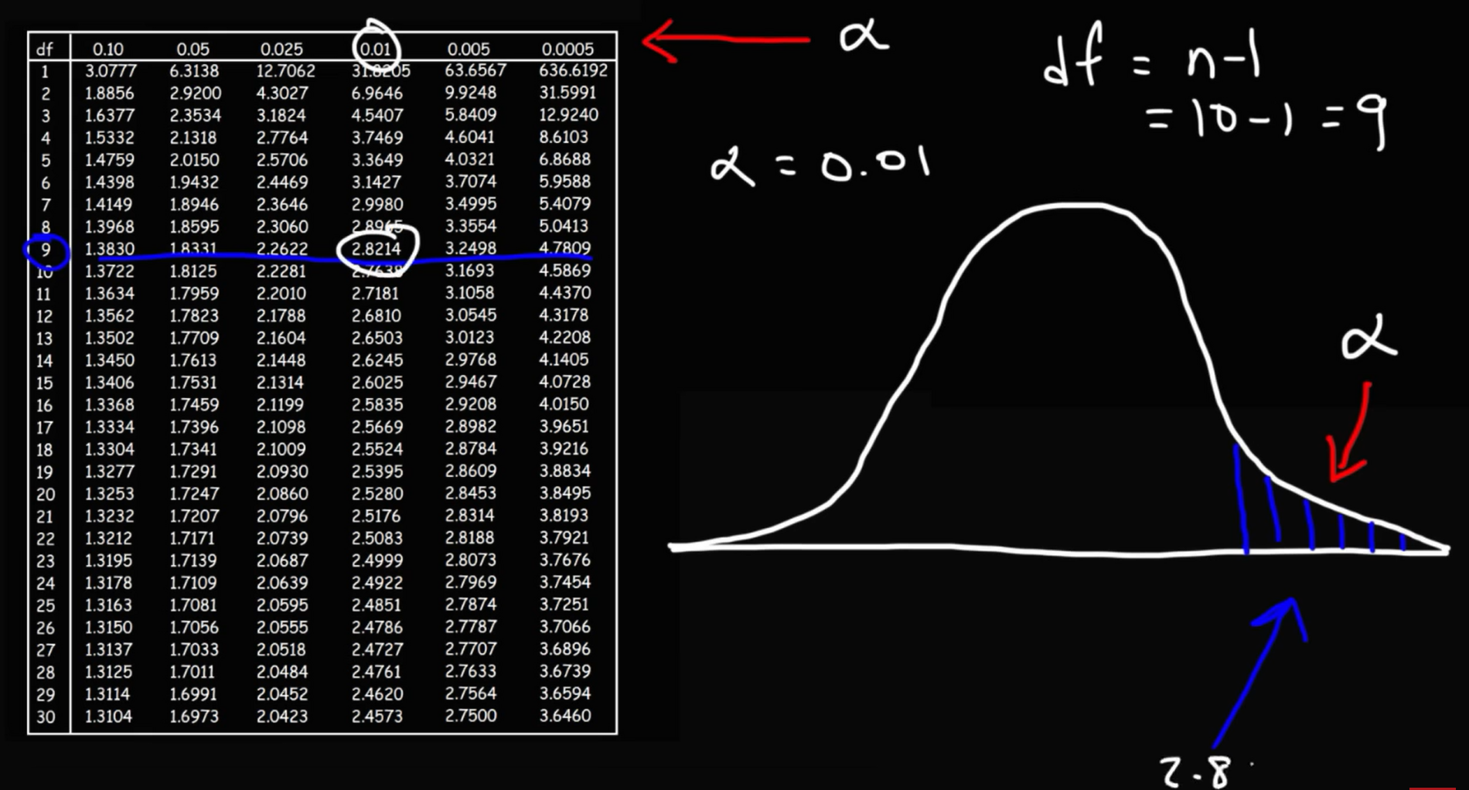

Bing Videos
https://www.bing.com/videos/riverview/relatedvideo?q=hypothesis%20testing%20numericals%20solved&mid=1F5B4F6B13FD3AED96AD1F5B4F6B13FD3AED96AD&ajaxhist=0

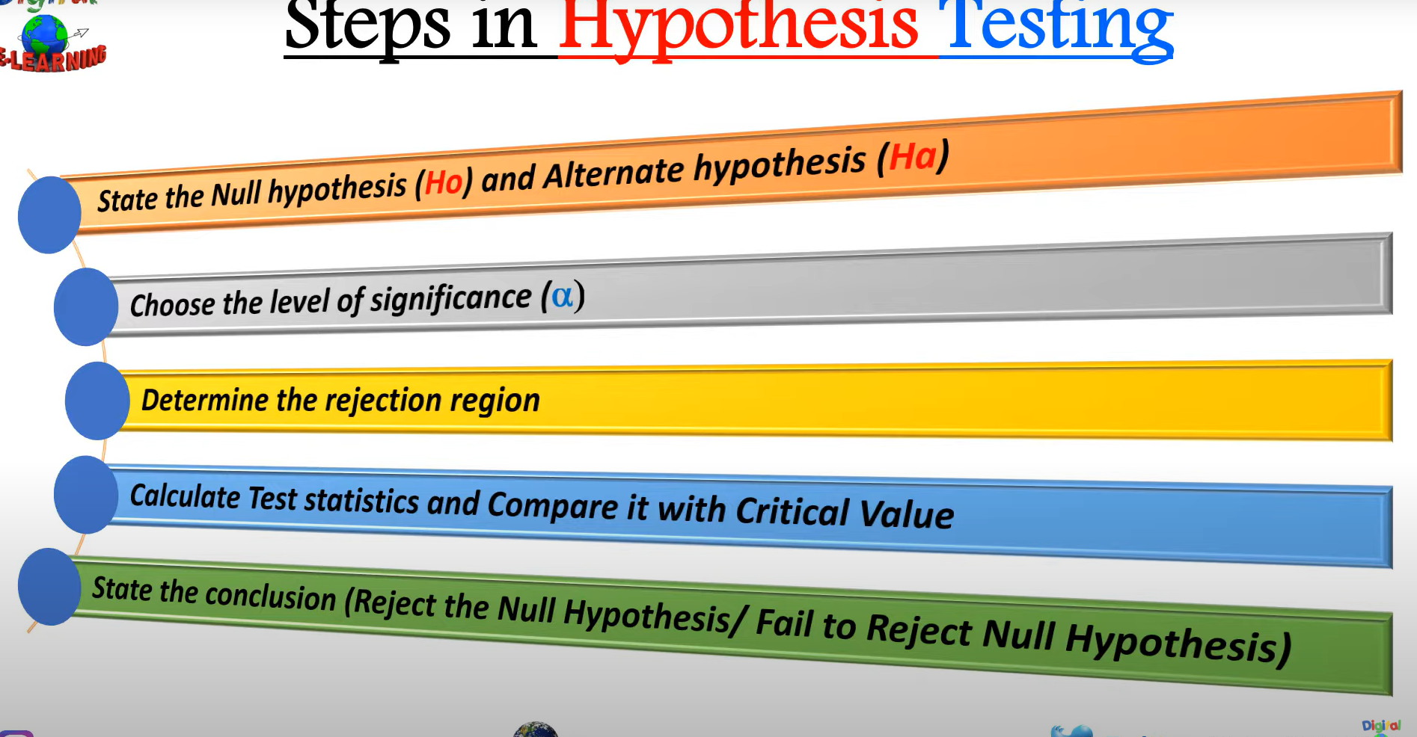
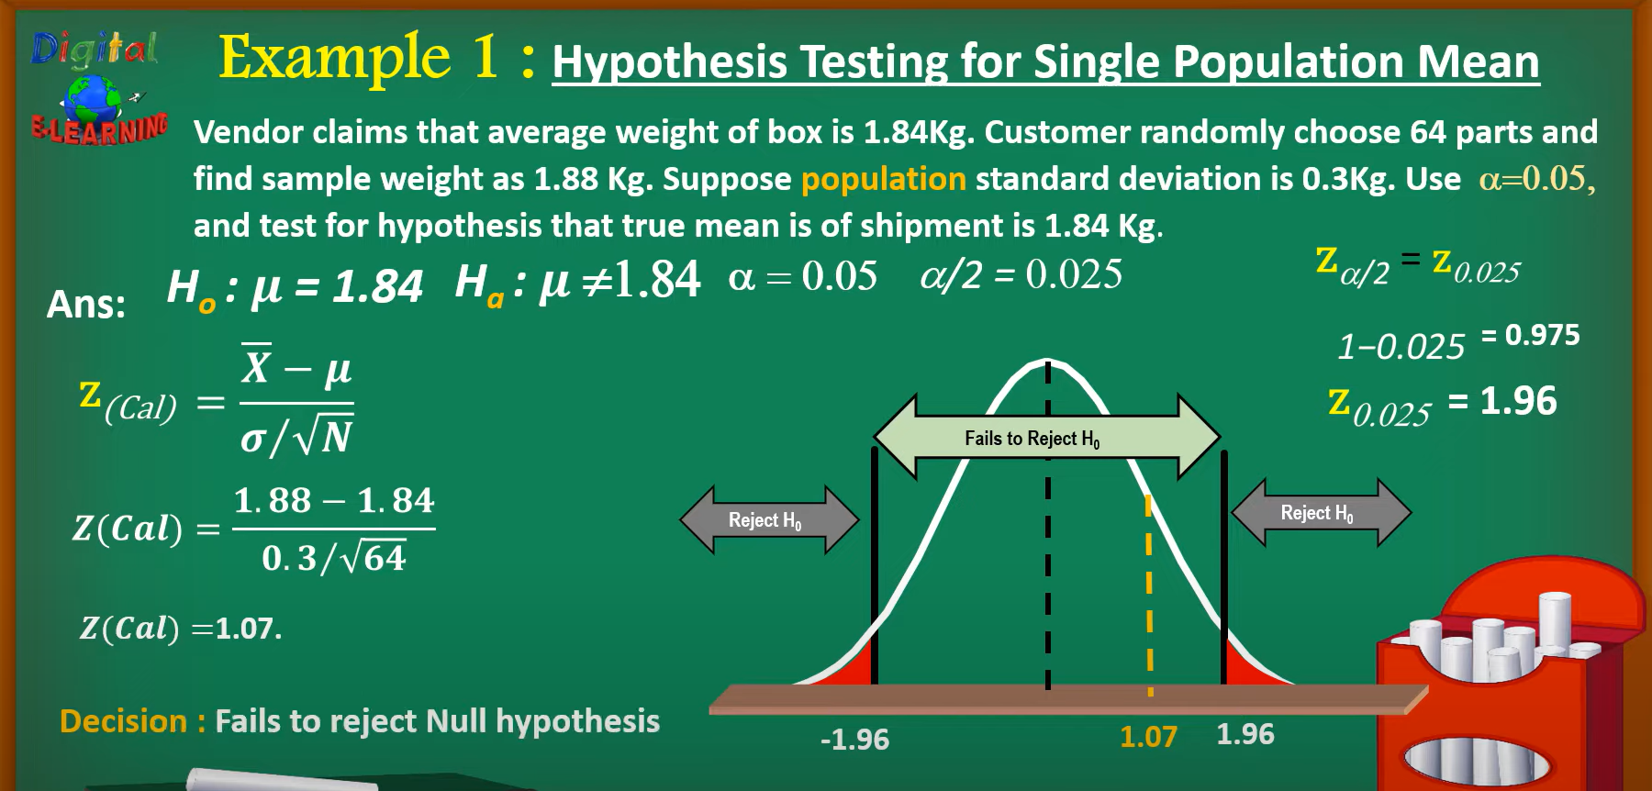
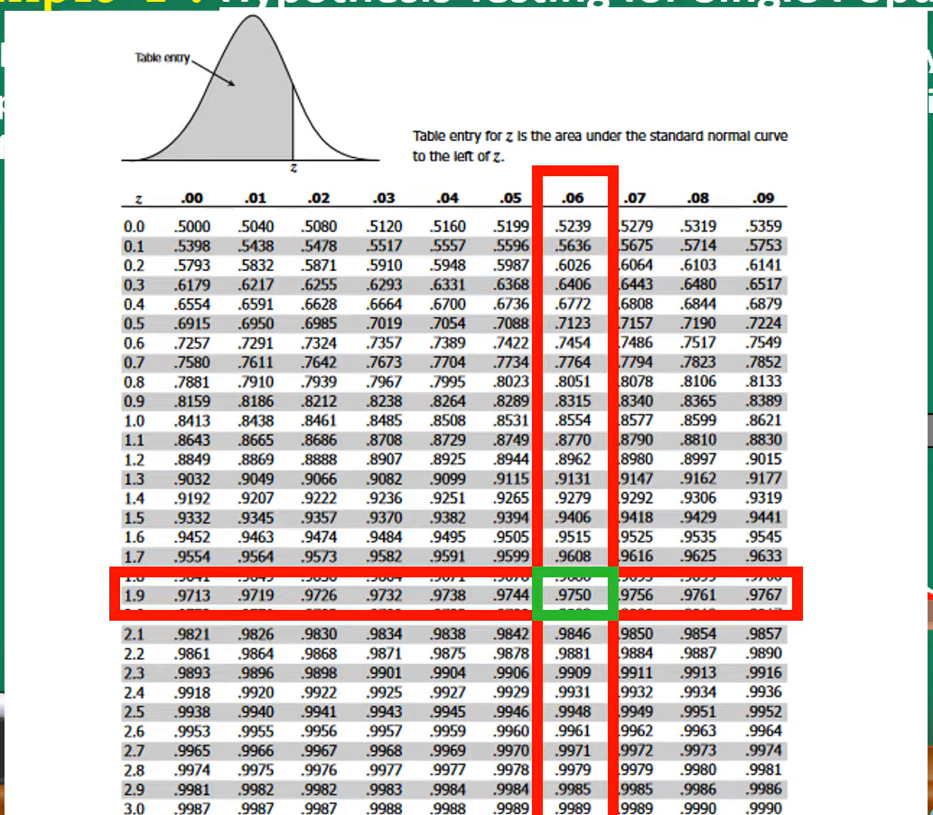

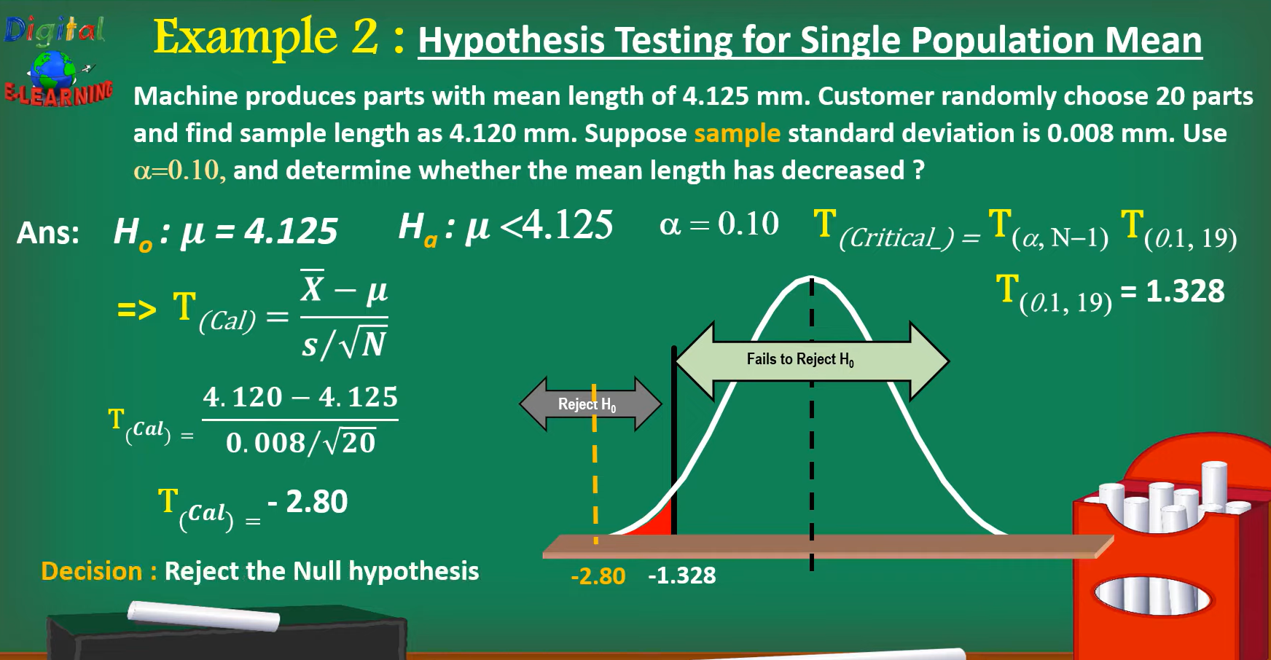

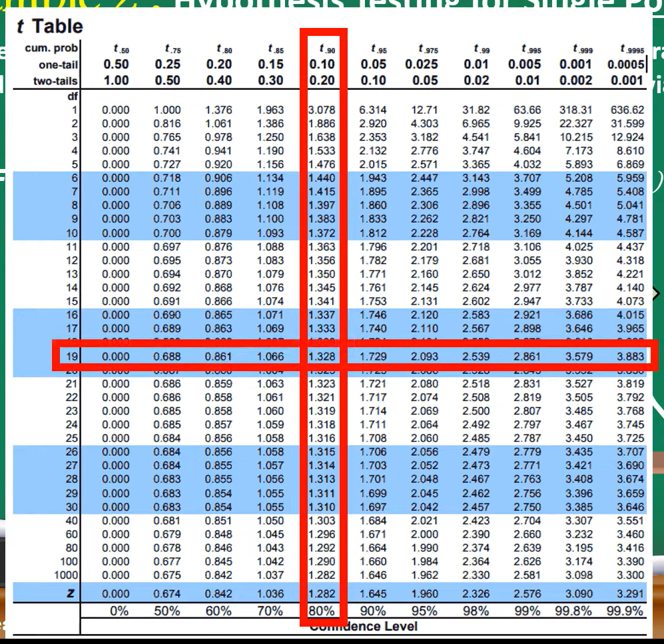

🎓 Problem Statement
A professor claims that the average exam score of her class is 75.
You collect a random sample of 20 students and find:
• Sample mean () = 78
• Sample standard deviation (s) = 10
You want to test whether the professor’s claim is correct at 5% significance level ().

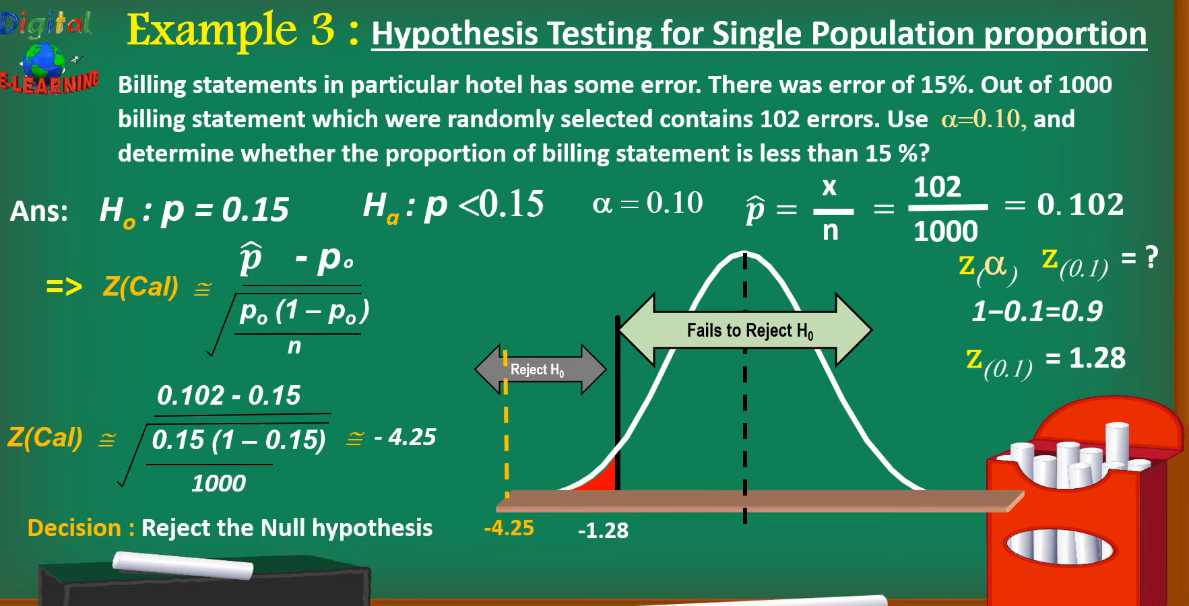
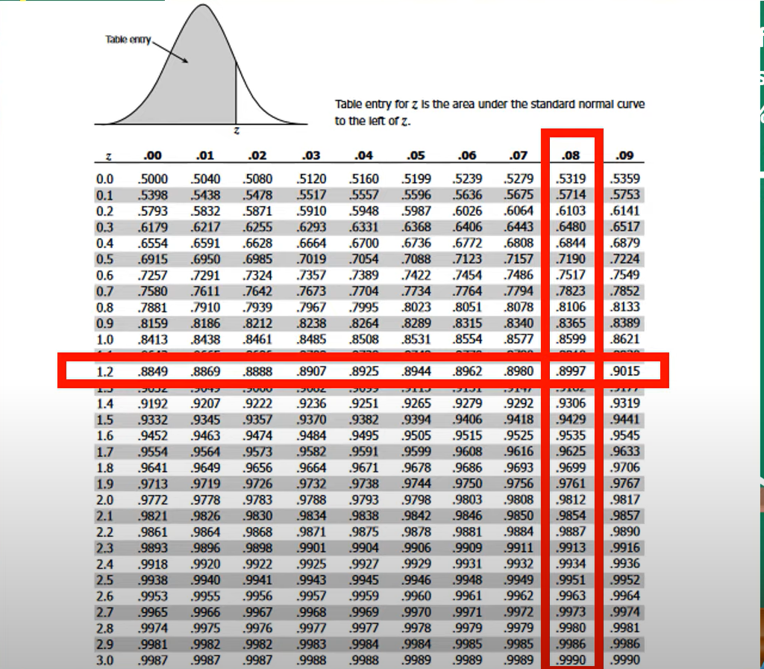

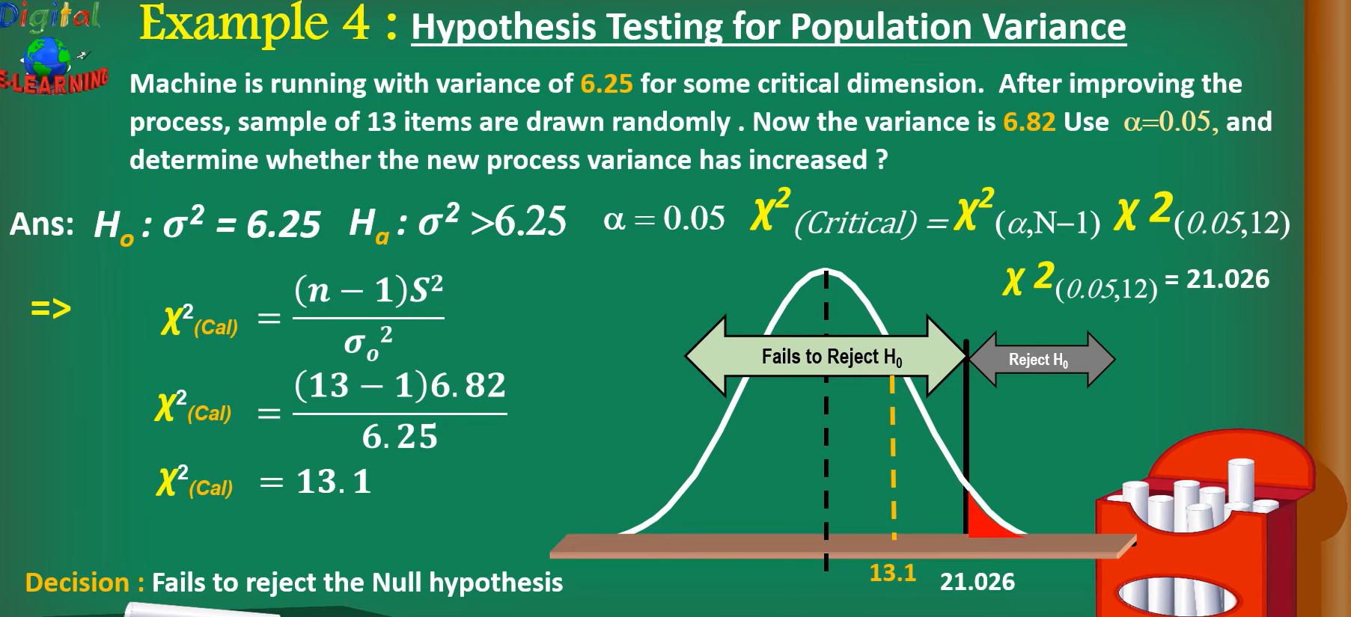

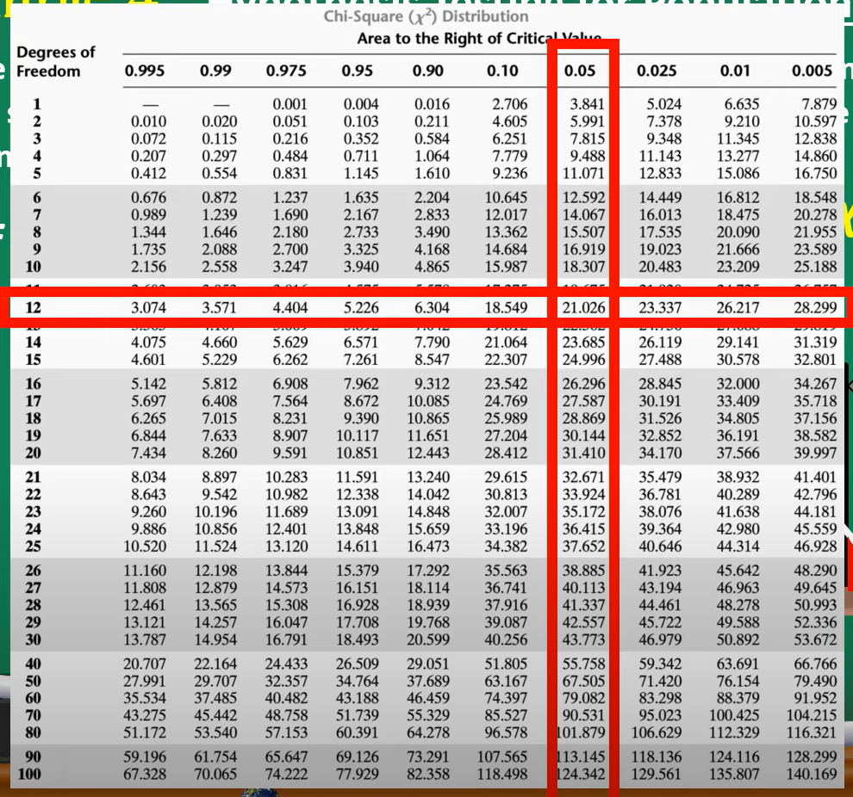
Exercises and solution also at
https://kindsonthegenius.com/blog/hypothesis-testing-solved-examplesquestions-and-solutions/

